**Roll No: 2021-CS-25**

**Name: Amad Irfan**

**Section: A**

**Session: 2021**

**Lab: 4**

**Ping:**

Ping command is use to configure with pc to pc.

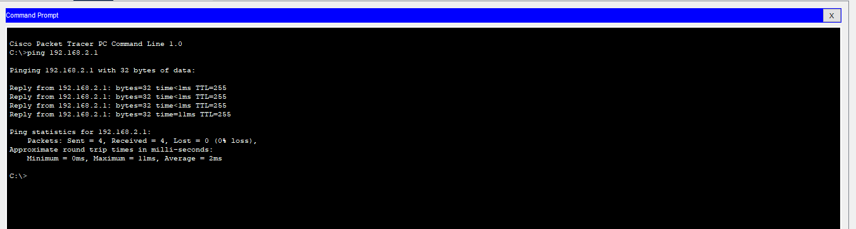**Enable:**

Enable command is use to enable router settings.

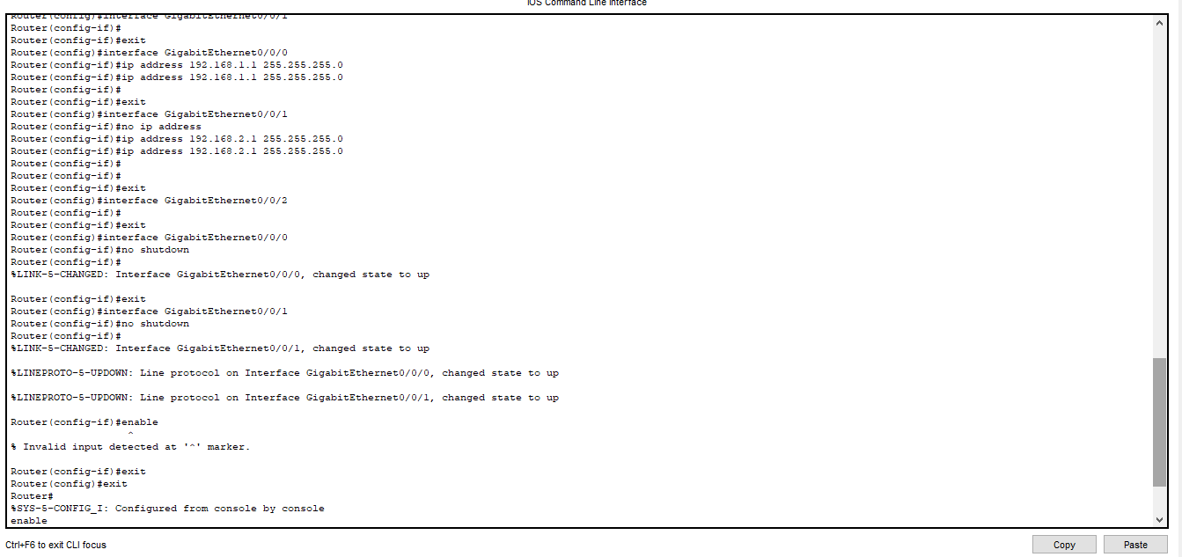

**Configure Terminal:**

Configure terminal is use to configure routers terminal.

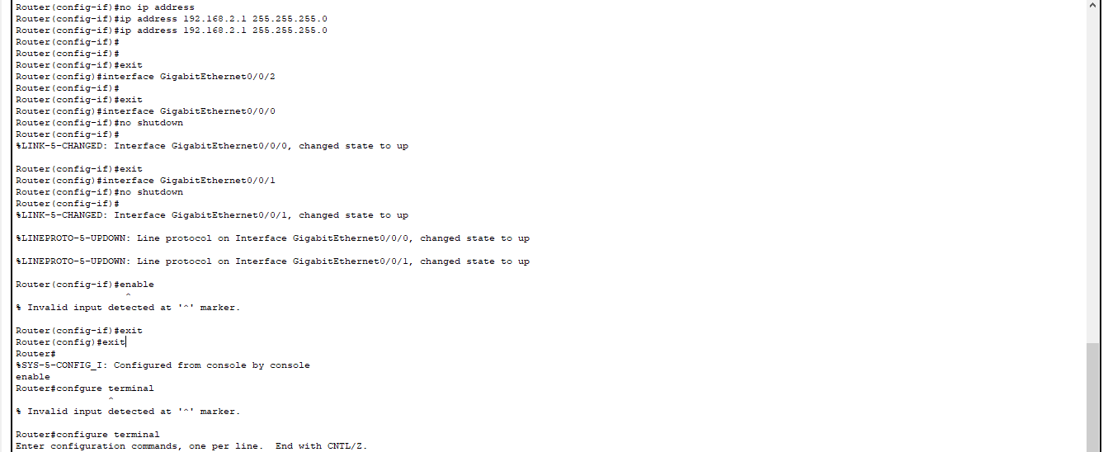

**Hostname:**

Host name command is use to configure routers name.

**Exit:**

Exit command is use to exit from routers configuration or other settings.

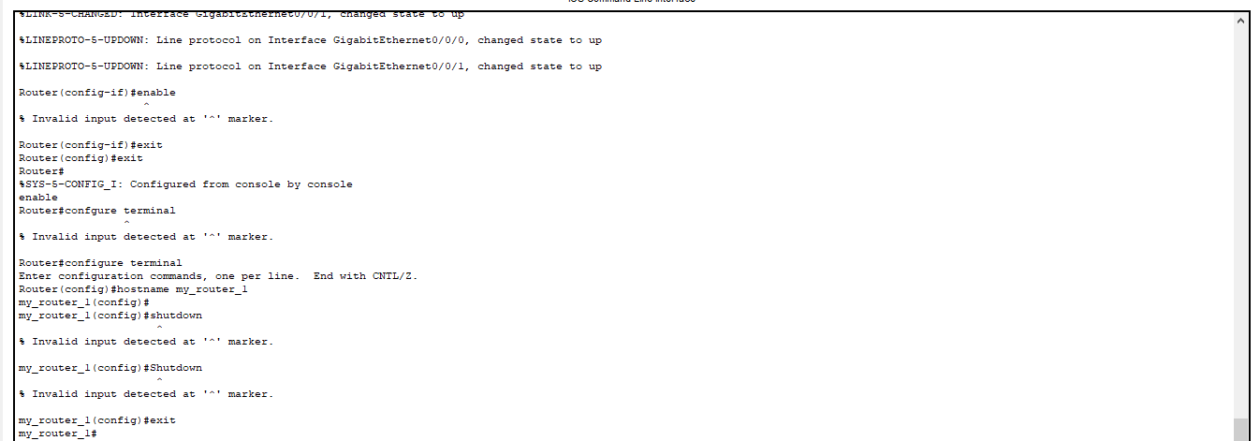

**Shutdown:**

Shutdown command is use to shutdown the router. But in my case this command is not running.

